2x1 DRS VIDEO WALL

1. MINIMUM CEILING HEIGHT REQUIREMENT IS 10’ 11”, RECOMMENDED HEIGHT IS 14’
2. Surveying the location and planning before the install is recommended to make installation easy, safe and successful. For example, the number of sign jacks and their locations should be determined before installation.
3. CAUTION: Always unplug the sign or any electricals prior to servicing, failure to comply may cause harm to the technician and could potentially damage the sign.
4. Re-use the foam provided in the packaging to protect the sign when moving parts to different locations.

IMPORTANT REMINDERS:

* SAFETY FIRST. Always team lift the sign module when taking the sign out of the packaging or any parts that are over 50 pounds.
* STAY FOCUSED. Be aware of the surroundings when moving the sign or lifting the sign out of the box, LED surfaces are fragile and are easily damaged.
* Prevent LEDs from making hard contact with metal or sharp object such as belt buckles, tool bags, badges or anything that can potentially damage LED panels.

|  |  |  |  |
| --- | --- | --- | --- |
| **Tool** | **Purpose** | **Quantity** | **Notes** |
| Telescoping Multi-Position Ladder | To extend the technician’s reach | 3 |  |
| Hand Tools | For hardware installation | 1 set / Installer | Screwdriver set, socket set w/ rachet, flush cutters, Allen wrench set |
| Power Tools | To increase install speed | 1 / Installer | Drill Gun, Impact Driver |
| Right Angle Attachment Tool | For hard to reach places | 1 / Installer |  |

LIST OF TOOLS & EQUIPMENT

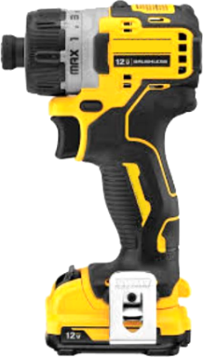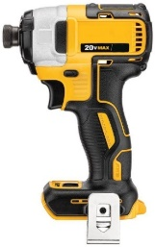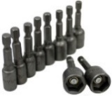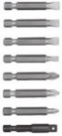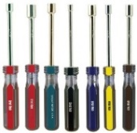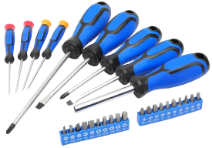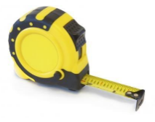

*Light Duty Cordless Screwdriver (ex. Electrical components etc.)*

*Heavy Duty Cordless Screwdriver (ex. Big Bolts and Nuts etc.)*

|  |  |
| --- | --- |
| **POWER CONSUMPTION**  ELECTRICAL INFORMATION | |
| **TOTAL CURRENT** |  |
| RECEPTACLES REQ’D: **5** | |

|  |  |  |
| --- | --- | --- |
| Part Number | Description | Qty. |
| HDW-25960-416 | 1/4 Black Flat Washer | 104 |
| HDW-20001-420 | 1/4-20 Hex Nut | 19 |
| HDW-20000-832 | 8-32 Hex Nut | 3 |
| HDW-50832-312 | 8-32 x 312 Black PPH Screw | 20 |
| HDW-82420-075 | 1/4-20 x .750 Black Hex Bolt | 97 |
| HDW-50832-375 | 8-32 x .375 PPH Screw | 12 |
| HDW-60832-375 | 8-32 x .375 Black Flat Head Screw | 18 |

***Include LED Panel Size (P2.5 x 160mm x 320mm, NO GOB) x 2 PCS***

***ELE-42001-100 Remote control x 1 PC***

***ELE-46610-602 Power strip- 6 position x 1 PC***

***ELE-46871-117 Adapter-Mini-DP/HDMI x 1 PC***

HARDWARE LIST

PARTS LIST

MEASUREMENT REFERENCES

1. Place Base Plate (FAB-03513-205) on the designated location.
2. Install the Pole Weldment (WLD-03513-115) on to the Base Plate.
3. Secure the Pole Weldment to the Base Plate with 4(x) 1/4 Black Flat Washers (HDW-25960-416) and 4(x) 1/4-20 Hex Nuts (HDW-20001-420).

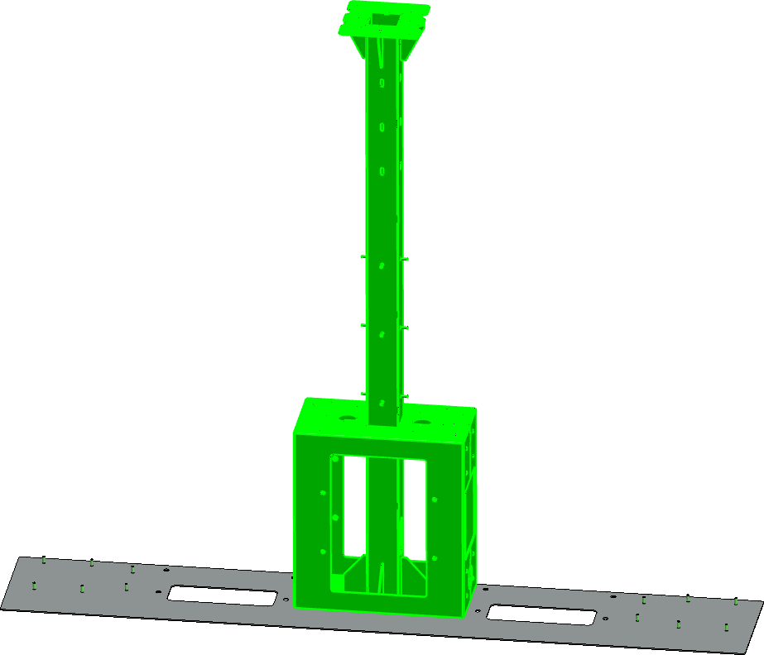

*Pole Weldment*

*(WLD-03513-115)*

*Base Plate*

*(FAB-03513-205)*

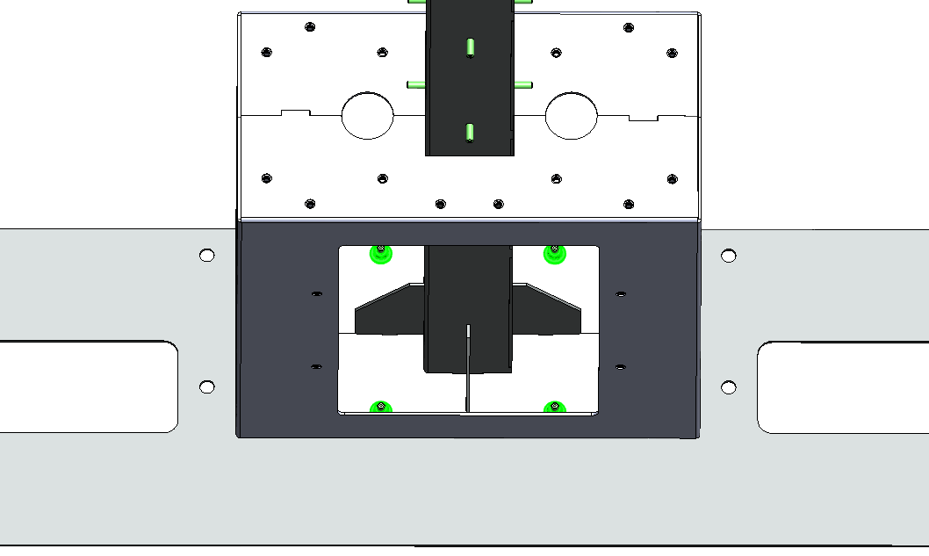

1. Uninstall the Pedestal Main Doors from the 2(x) Gambler Pedestals (ASY-03513-115).

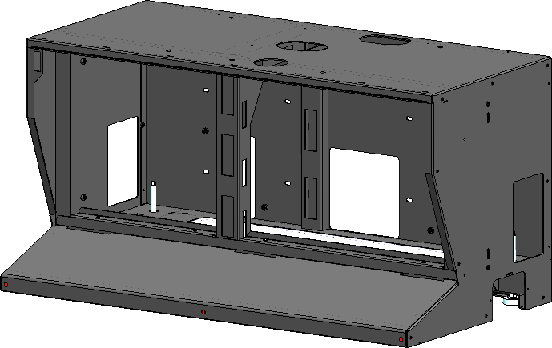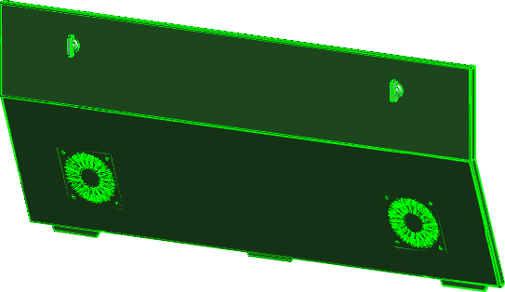

1. Secure the 2(x) Wedge Brackets to the Pedestals and Base Plate with 10(x) 1/4 Black Flat Washers (HDW-25960-416), 6(x) 1/4-20 x .750 Black Hex Bolts (HDW-82420-075) and 4(x) 1/4-20 Hex Nut (HDW-20001-420), 5(x) Flat Washers, 3(x) Hex Bolts and 2(x) Hex Nuts per Wedge Bracket.
2. Install the 2(x) Wedge Stop Brackets (FAB-03513-089) to the back of each Pedestal.

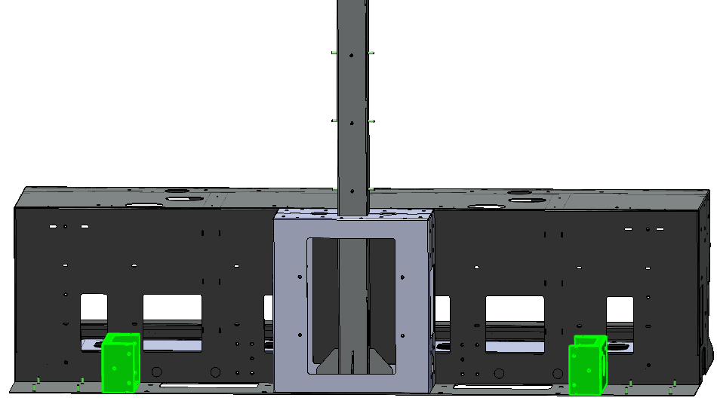

*Wedge Stop Brackets*

*(FAB-03513-089)*

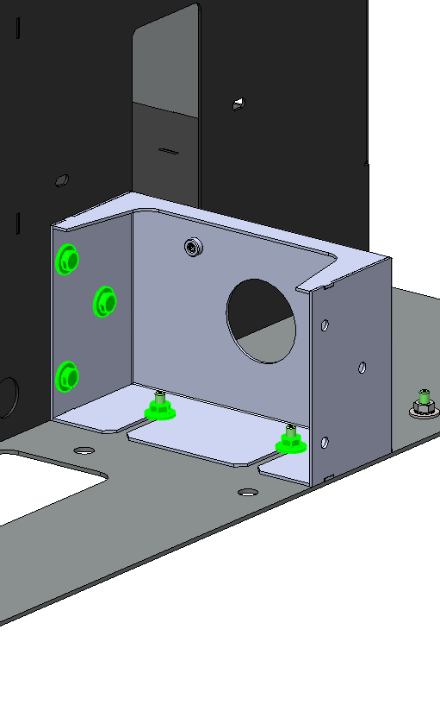

1. Secure the first Pedestals with 4(x) 1/4 Black Flat Washers (HDW-25960-416) and 4(x) 1/4-20 x .750 Black Hex Bolts (HDW-82420-075), 2(x) Flat Washers and Hex Bolts per Pedestal.
2. Install 2(x) Gambler Pedestals in front of the Pole Weldment as shown on the drawing below.

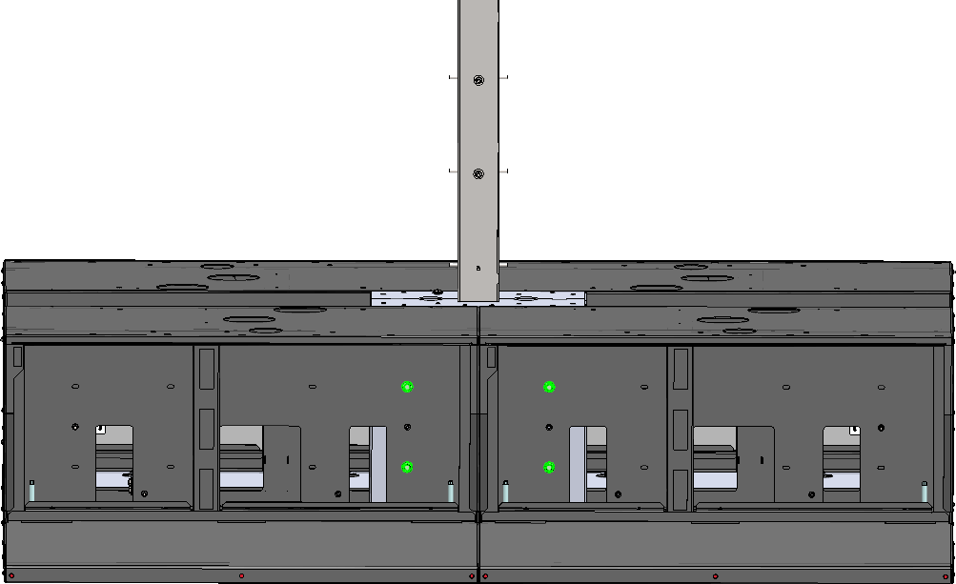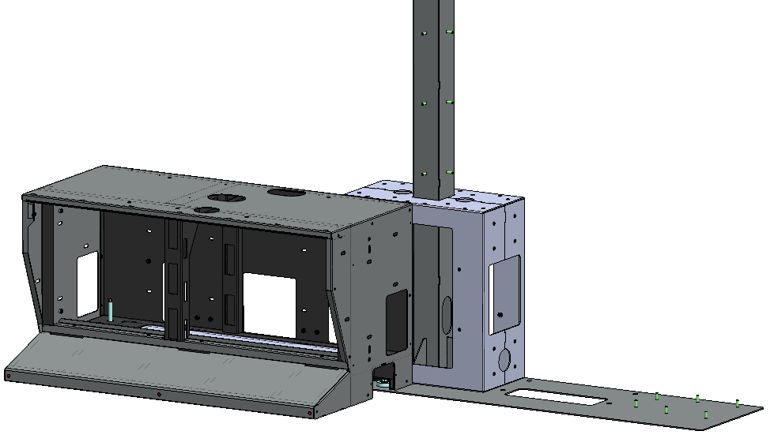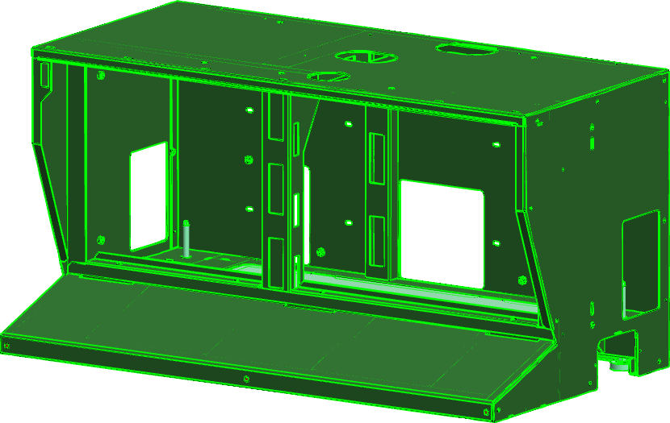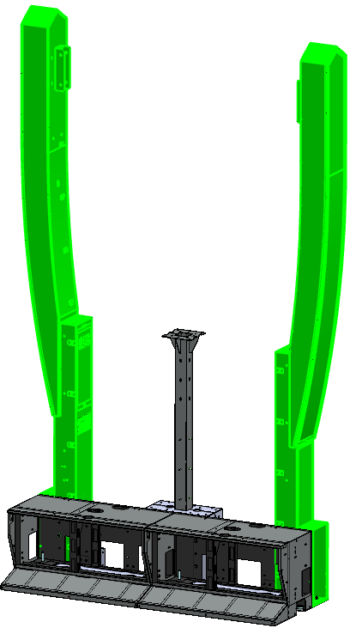

*Primary Wedges*

*(WDG-03513-100)*

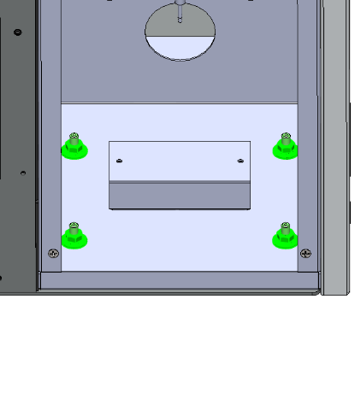

1. Install the 2(x) Primary Wedges (WDG-03513-100) on both ends of the Pole Plate.

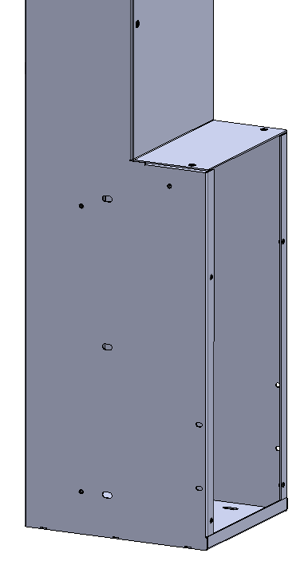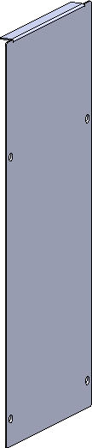

1. Remove 8(x) 8-32 x .375 Flat Head Screws to uninstall the Primary Wedge Main Doors, 4(x) PPH Screws per Wedge.

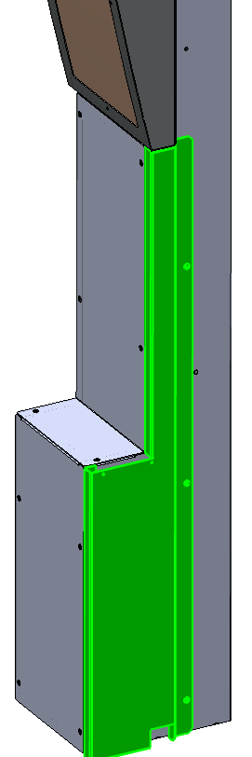

*Single Face Trims*

*(WLD-03513-325)*

*Primary Wedge*

*Primary Wedge*

1. Install and secure the 2(x) Single Face Trims (WLD-03513-325) to the back side of the Wedges with 6(x) 8-32 x .375 PPH Screws (HDW-50832-375), 3(x) PPH Screws per Trim.
2. Secure the bottom of the 2(x) Primary Wedges (from inside the Wedge) to the Base Plates with 8(x) 1/4 Black Flat Washers (HDW-25960-416) and 8(x) 1/4- Hex Nuts (HDW-20001-420), 4(x) Flat Washers, 4(x) Hex Nuts per Wedge.
3. Secure the 2(x) Primary Wedges (from inside the Wedge) to the Pedestals and Wedge Brackets with 10(x) 1/4 Black Flat Washers (HDW-25960-416), 10(x) 1/4-20 x .750 Black Hex Bolts (HDW-82420-075), 5(x) Flat Washers, 5(x) Hex Bolts per Wedge.

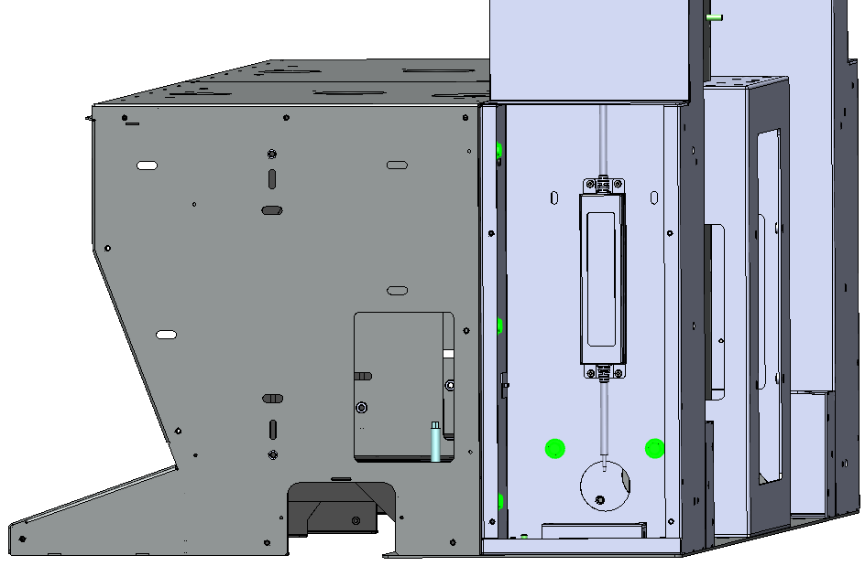

1. Install Pole Plate (FAB-03513-034) on top of Pole Weldment Mount Plate and to the 2(x) Wedges ledges.
2. Secure the 2(x) Pedestals together from inside with 2(x) 1/4 Black Flat Washers (HDW-25960-416) and 4(x) 1/4-20 x .750 Black Hex Bolts (HDW-82420-075), adjust the 2(x) Adjustment Bolts to prevent damaging the Pedestal before securing the 2(x) pedestals together.

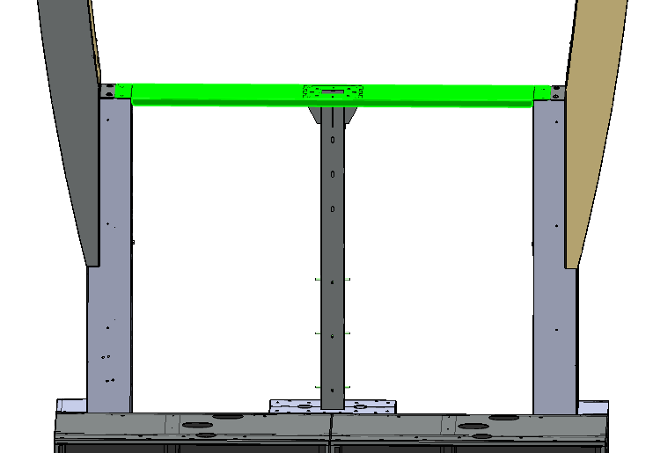

*Pole Plate*

*(FAB-03513-034)*

*Note: the footrest cover was made transparent to show details.*

1. Secure the Pole Plate to the Pole Weldment and to the 2(x) Wedges with 8(x) 1/4 Black Flat Washers (HDW-25960-416) and 8(x) 1/4-20 x .750 Black Hex Bolts (HDW-82420-075).

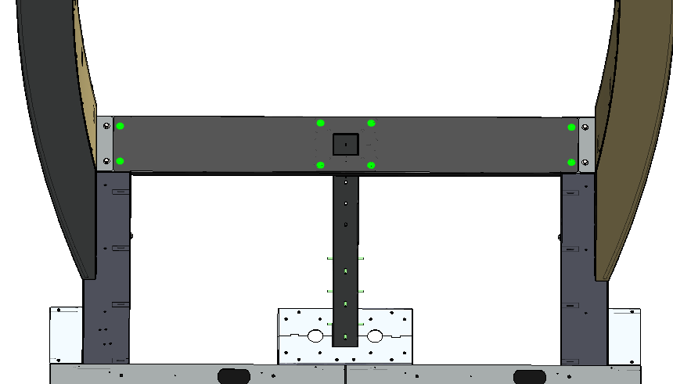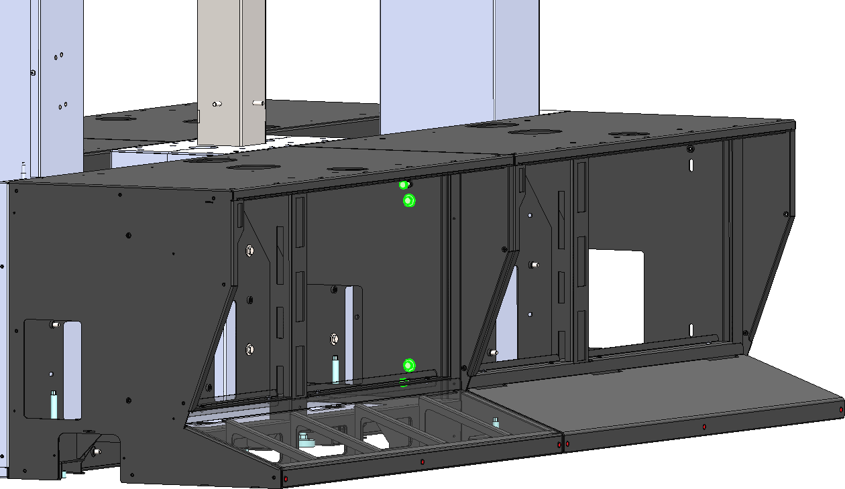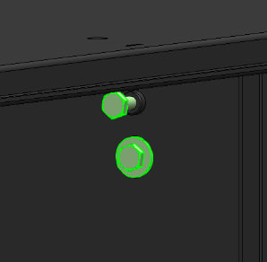

*Adjustment Bolts*

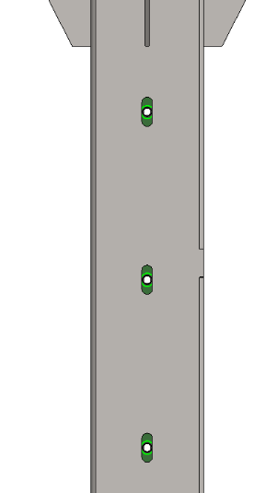

*Align holes*

1. Align the Pole Weldment slotted holes to the Top Half Assembly threaded holes.
2. Install the Pole Top Half Assembly into the Pole Weldment, from the Pole Tip to the Pole Plate (floor) is approximately 122.5 inches or 63.7. See drawing above for measurement references.

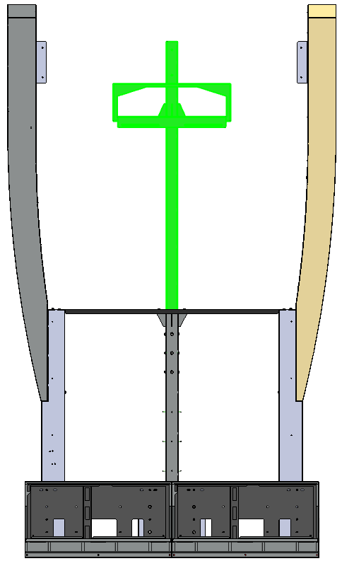

122.5

63.7

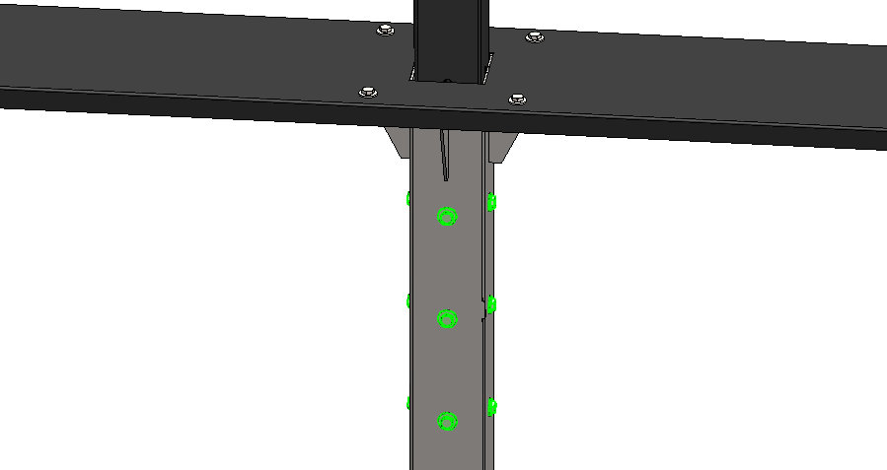

*12(x) 1/4 Black Flat Washers*

*(HDW-25960-416)*

*12(x) 1/4-20 x .750 Black Hex Bolt*

*(HDW-82420-075)*

1. Secure Pole Weldment to Pole Top Half Assembly with 12(x) 1/4 Black Flat Washers (HDW-25960-416) and 12(x) 1/4-20 x .750 Black Hex Bolts (HDW-82420-075).

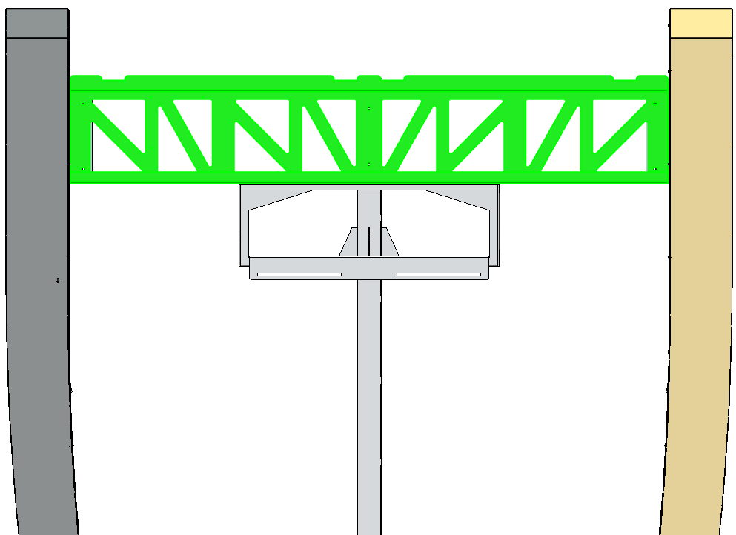

*Pole Arm Bracket*

*2x2 Signage Hanger Shelf*

*(FAB-03513-045)*

1. Install the 2x2 Signage Hanger Shelf (FAB-03513-045) on top of the Pole Arm Bracket.
2. Secure the Signage Hanger to the Top Pole Arm Bracket with 3(x) 1/4 Black Flat Washers (HDW-25960-416) and 3(x) 1/4-20 x .750 Black Hex Bolts (HDW-82420-075).
3. Secure the Signage Hanger to the Top Pole with 2(x) 1/4 Black Flat Washers (HDW-25960-416) and 2(x) 1/4-20 x .750 Black Hex Bolts (HDW-82420-075).

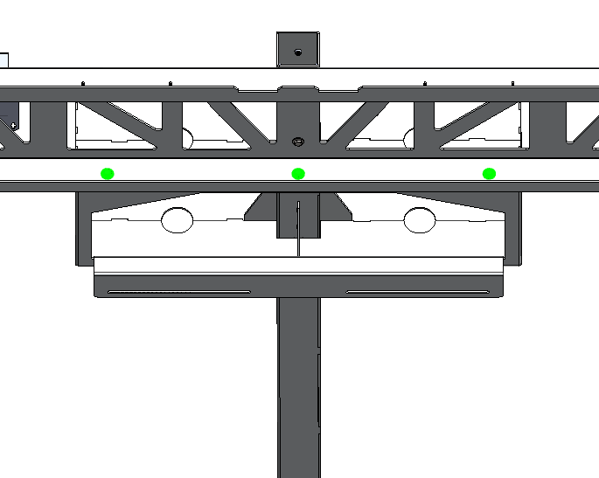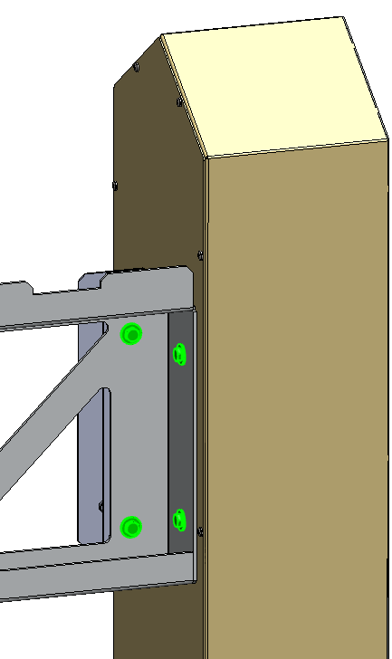

*Right Wedge*

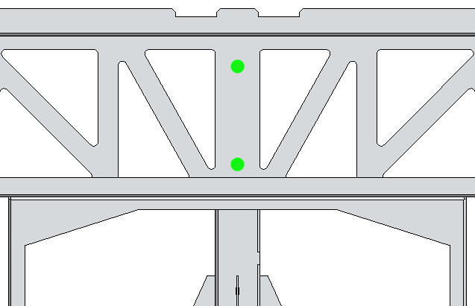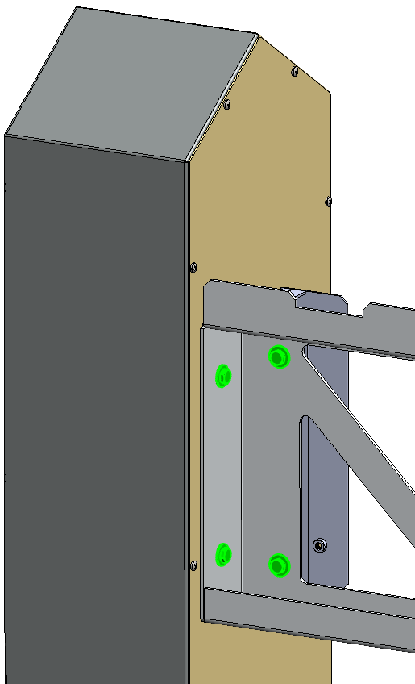

*Left Wedge*

1. Secure the ends of the Hanger Shelf to the left and right Primary Wedges with 8(x) 1/4 Black Flat Washers (HDW-25960-416) and 8(x) 1/4-20 x .750 Black Hex Bolts (HDW-82420-075), 4(x) Flat Washers and Hex Bolts for each end.

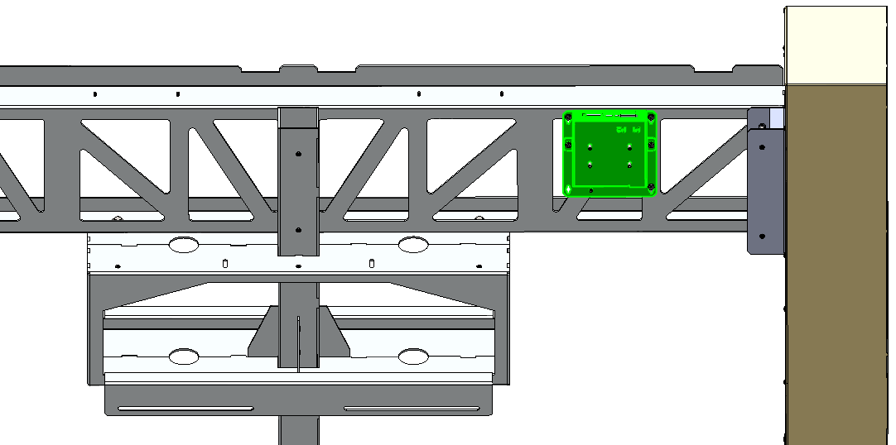

*Sending Unit Assembly*

*(ASY-03482-200)*

1. Secure the Sending Unit to the Hanger Shelf with 3(x) 8-32 Hex Nuts (HDW-20000-832).
2. Install 1(x) Sending Unit Assembly (ASY-03482-200) to the 3(x) studs located behind Hanger Shelf.

1. Uninstall the Top Sign LED Unit Assemblies Back Covers by removing 10(x) 1/4 Flat Washers and 10(x) 1/4-20 x .750 Black Hex Bolts, 5(x) Flat Washer and 5(x) Hex Bolts per LED Unit.

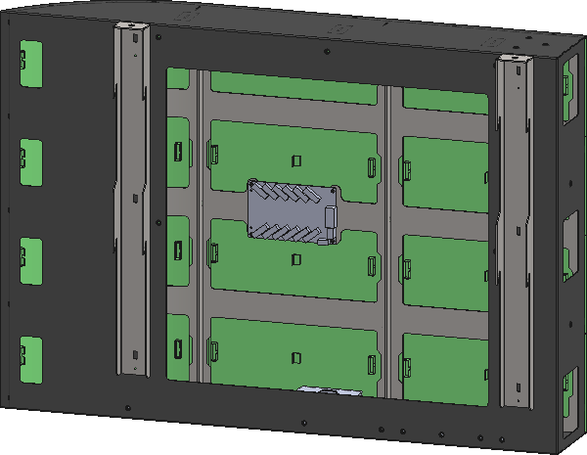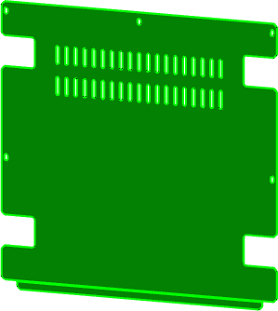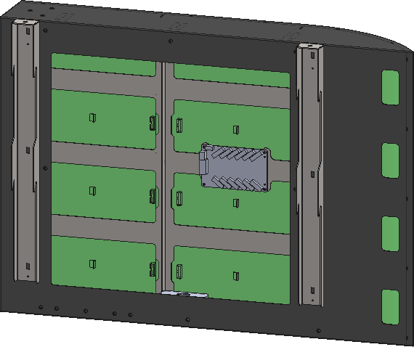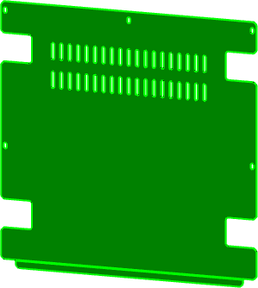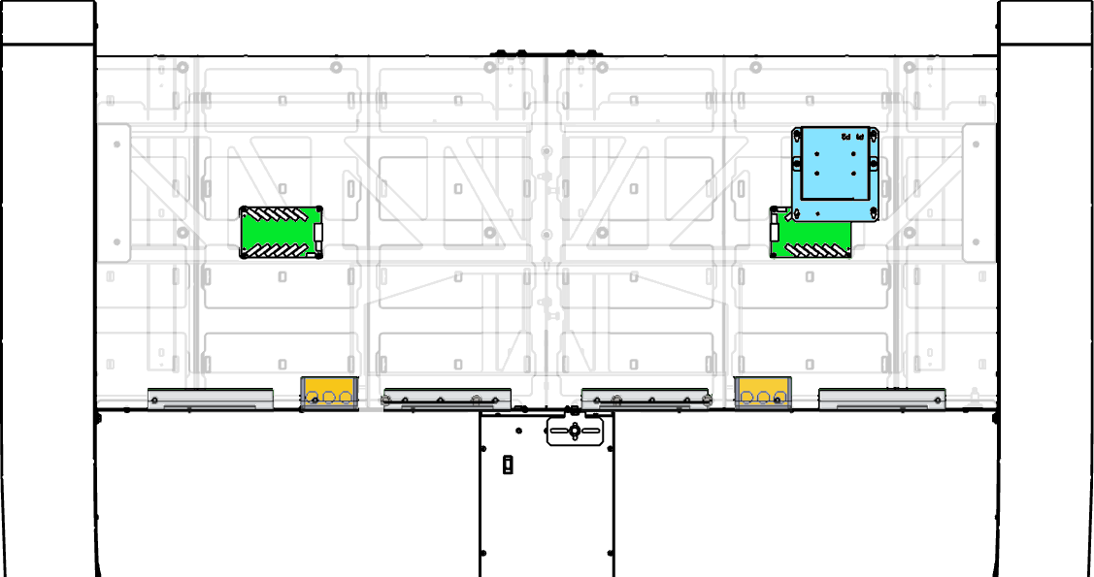

***Power Supply 4***

***Power Supply 3***

***Power Supply 2***

***Power Supply 1***

*Insert Power Cord down into the Pole.*

*See Page 18.*

***Sending Unit 1***

***B-B***

***A-A***

DC CONNECTIONS



***Sending Unit 1 (P1)***

***RC2***

***RC1***

***1-1***

*Connect CAT5 Cable from Sending Unit (P1) to RC1 (N)*

DATA CONNECTIONS

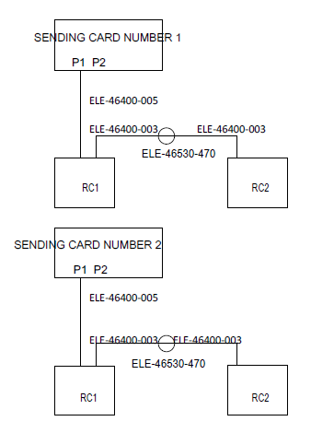

SENDING UNIT

1. To install the Left Top Sign LED Unit (ASY-03513-135), hang the Top Sign (locate the hooks behind the Top Sign) into the Signage Hanger (as shown below).
2. To install the Right Top Sign (ASY-03513-140) Right Top Sign LED Unit, hang the Top Sign (locate the hooks behind the Top Sign) into the Signage Hanger (as shown below).

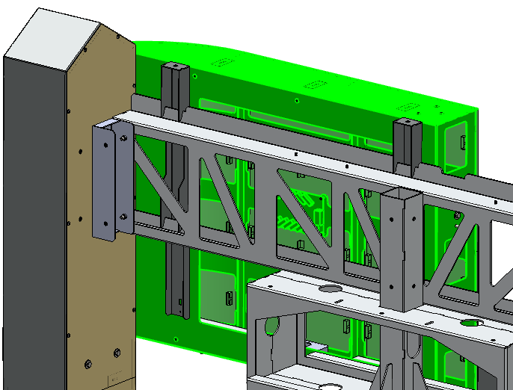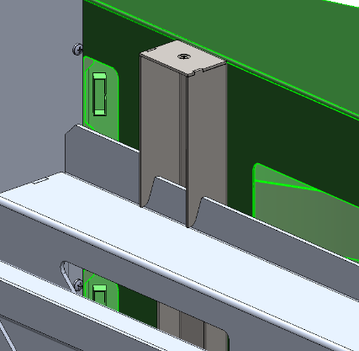

*Hooks*

*Gambler Left Top Sign*

*(ASY-03513-135)*

*Gambler Right Top Sign*

*(ASY-03513-140)*

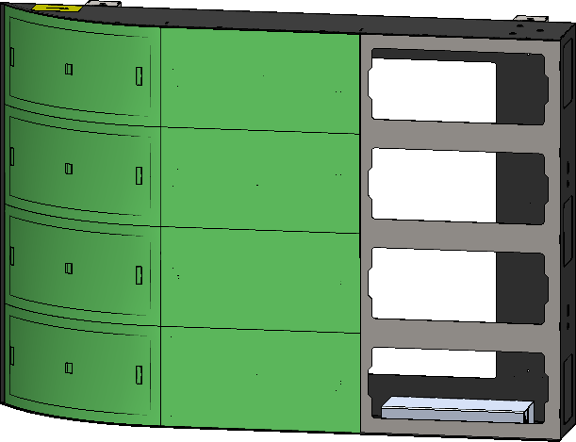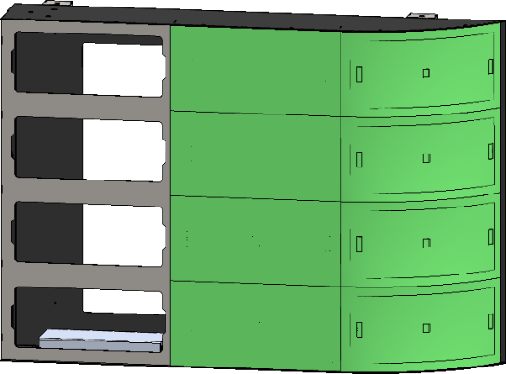

*Note: Viewed from the back*

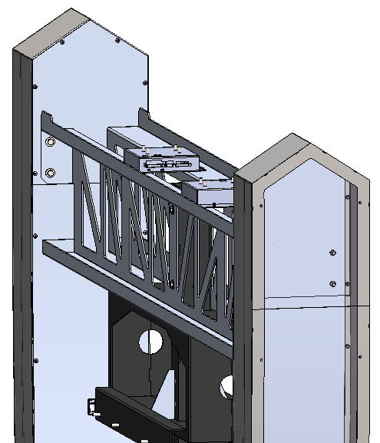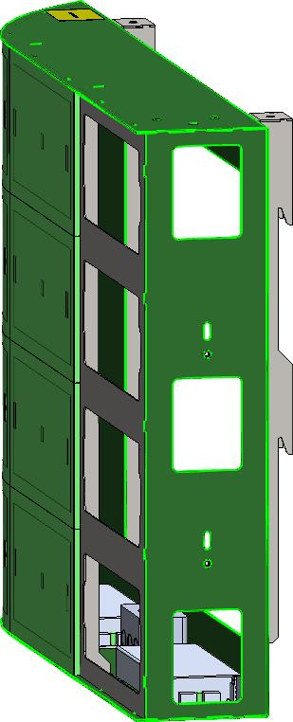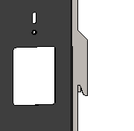

*Hooks*

1. Uninstall 8(x) LED Panels from the 2(x) Top Sign LED Units (ASY-03513-135 and ASY-03513-140), 4(x) LED panels per Top Sign half. To uninstall the LED Panels, unplug the Power and Data connectors from the LED Panels. Put LED Panels in a safe area to prevent damage.

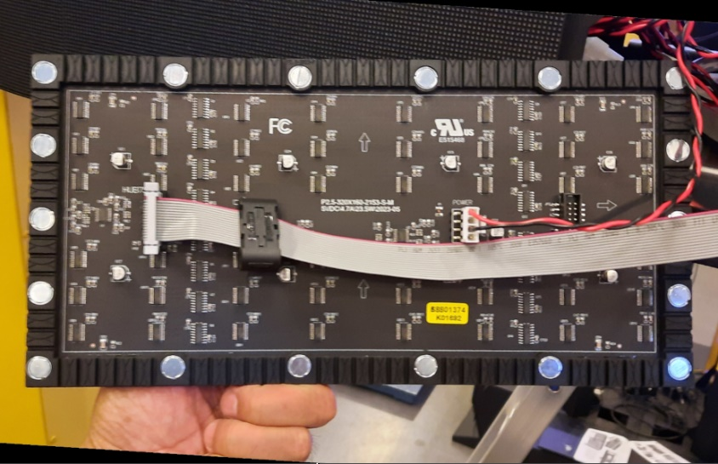

***Power***

***Data***

1. Install 2(x) Adjustment Bolts 1/4-20 x .750 Black Hex Bolts (HDW-82420-075) to the Panel Mount of the LED Panel.
2. Install the Right Top Sign LED Unit (ASY-03513-140) to the right side of the previously installed left Top Sign, hang the Top Sign (locate the hooks behind the Top Sign) into the Signage Hanger.
3. Align the 2(x) Sign modules, ensure there are no gaps between LED panels. Secure the 2(x) Sign Modules with 2(x) 1/4 Black Flat Washers (HDW-25960-416) and 2(x) 1/4-20 x .750 Black Hex Bolts (HDW-82420-075).

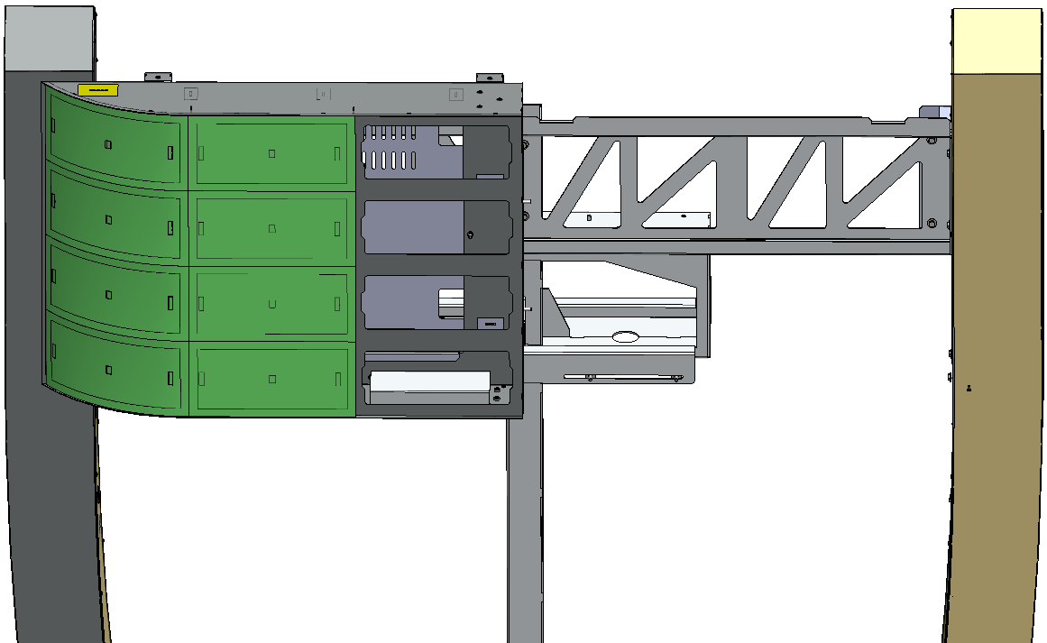

*Left Top Sign*

*(ASY-03513-135)*

*Right Top Sign*

*(ASY-03513-140)*

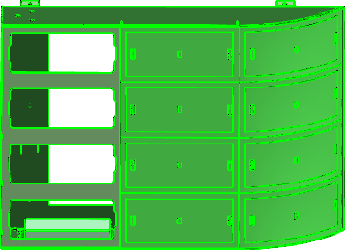

1. Reinstall 8(x) LED Panels to the 2(x) Left and Right Top Sign LED Units (ASY-03513-135 and 2x ASY-03513-140), 4(x) LED panels per Top Sign LED Unit. To install the LED Panels, plug the Power and Data connectors to the LED Panels as shown on the left picture below.

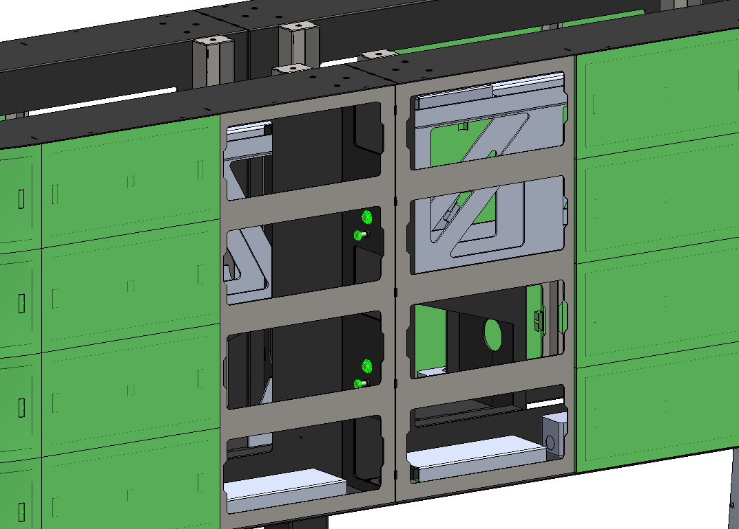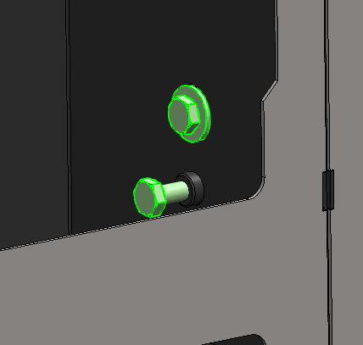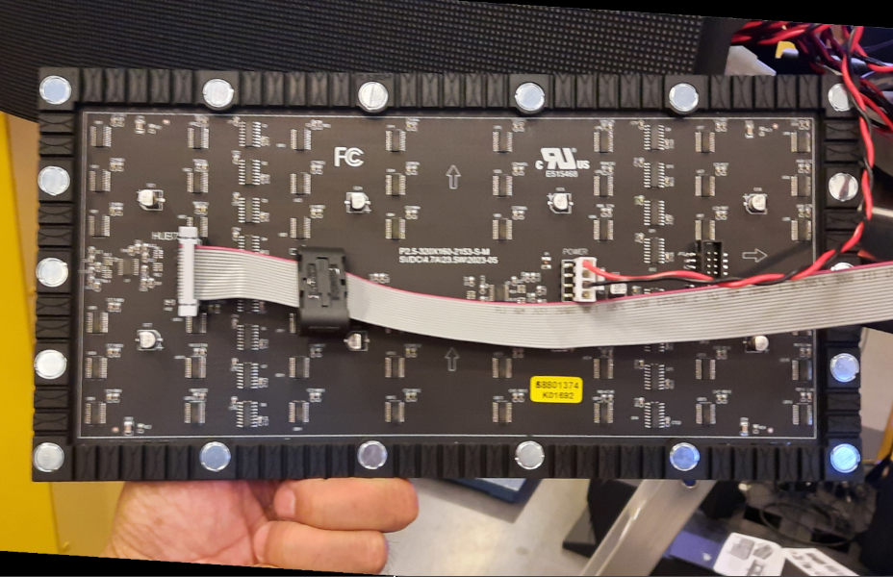

***Power***

***Data***

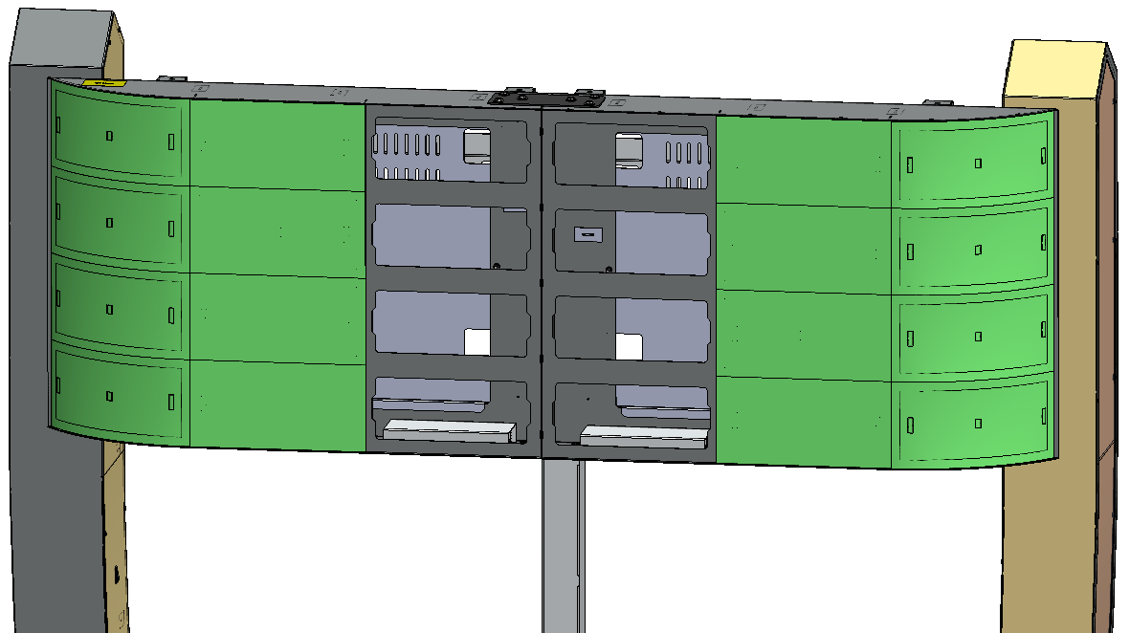

*Left Top Sign LED Unit*

*(ASY-03513-135)*

*Right Top Sign LED Unit*

*(ASY-03513-140)*



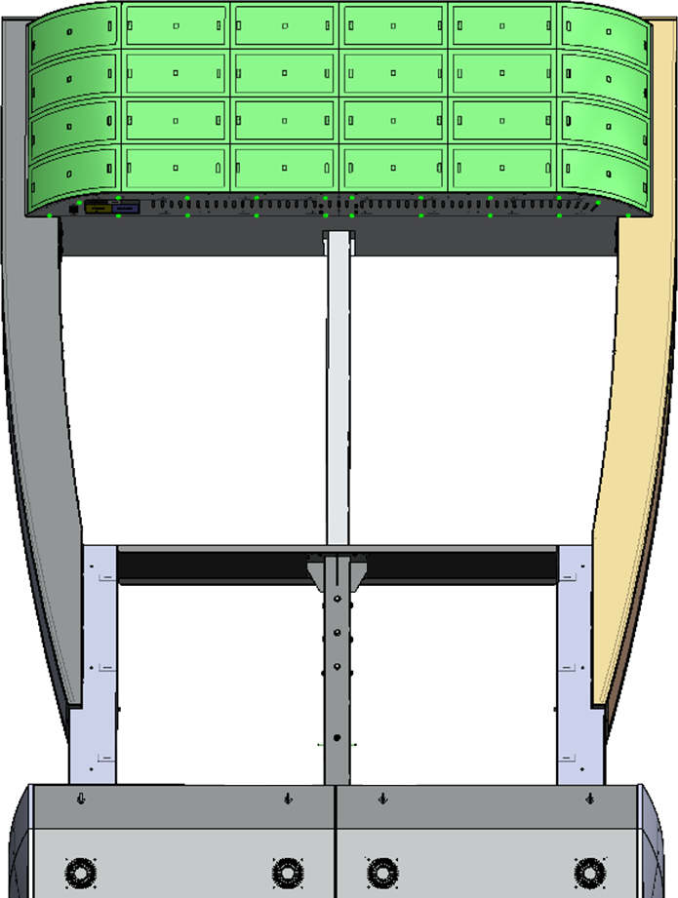

1. Install the Signage Bottom Cover (FAB-03513-230) underneath the Sign assembly with 20(x) 8-32 x 312 Black PPH Screws (HDW-50832-312).

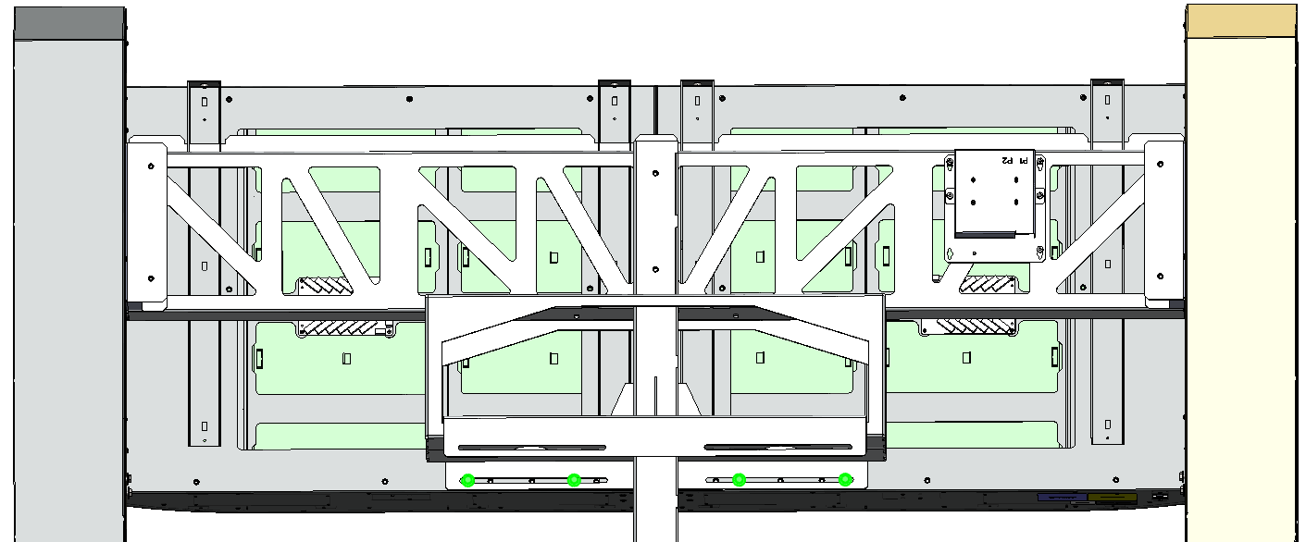

1. Install and secure the Connect Bracket (FAB-03513-079) to secure the Top Signs LED Units together with 6(x) 1/4 Black Flat Washers (HDW-25960-416) and 6(x) 1/4-20 x .750 Black Hex Bolts (HDW-82420-075).
2. Secure 2x2 Gambler Left and Right Top Signs to the Pole Bracket with 4(x) 1/4 Black Flat Washers (HDW-25960-416) and 4(x) 1/4-20 x .750 Black Hex Bolts (HDW-82420-075).

1. Uninstall the AC Plug from the Power Cord. DO NOT LOSE PARTS.
2. Insert the Power Cord and HDMI Cables into the Pole.

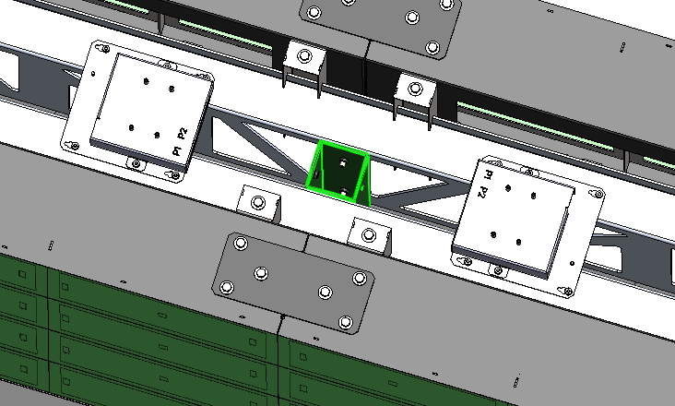

1. Grab and pull the Power and the HDMI Cables from the Pole access hole.
2. Prepare the Power Cord for the Plug installation.

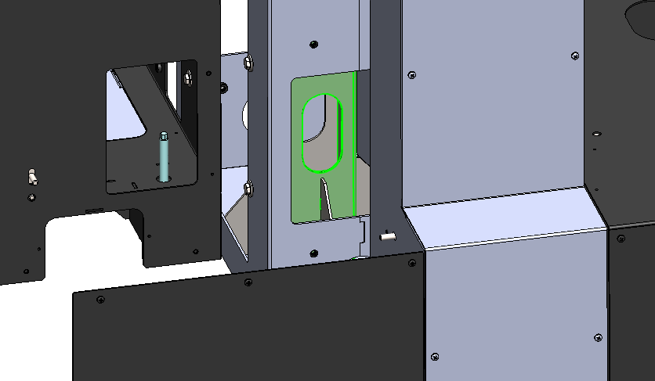

***Bottom Pole Access Hole***

1. Insert the Corn into the Body Cover.
2. Insert the Black Wire where the Gold Screw on the side is. Tighten Screw.
3. Insert the White Wire where the Silver Screw on the side is. Tighten Screw.
4. Insert the Green Wire where the Green Screw on the side is. Tighten Screw.
5. Finish the Plug installation.

***USE STEPS 37 to 45 AS REFERENCE IN CASE THE PLUG HAS TO BE UNINSTALLED.***

1. Install the Small Wedge (WDG-03513-120) to the Pole Panel (center of the Staging assembly as shown on the drawing below).
2. Uninstall the Small Wedge Covers from the Small Wedge (WDG-03513-120) by removing the 6(x) 8-32 x 312 Black PPH Screws.

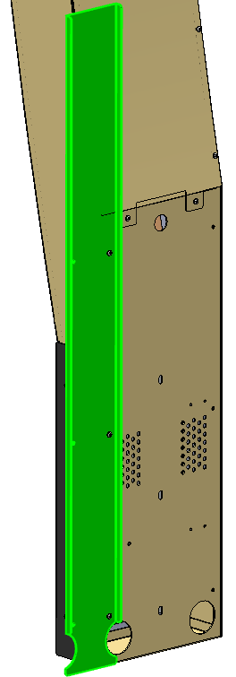

*Trash Block Out Panels*

*(FAB-03513-242)*

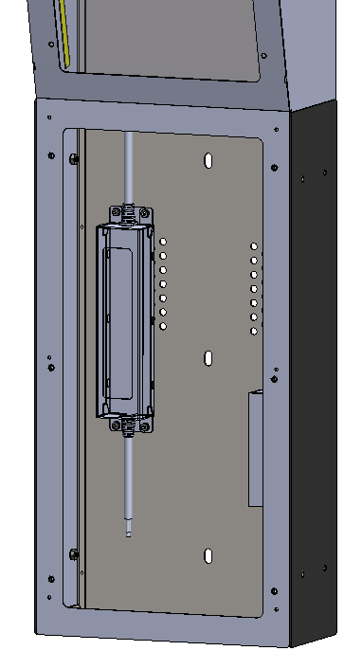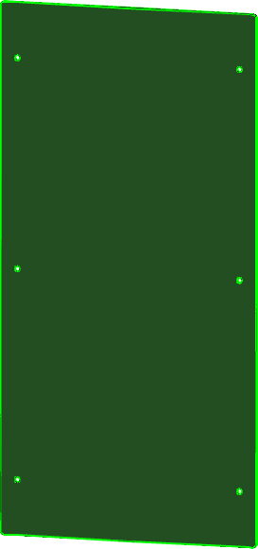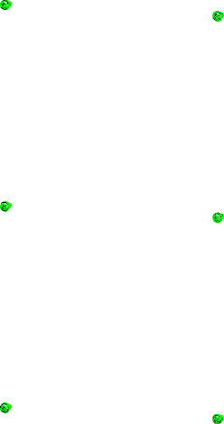

1. Install the 2(x) Trash Block Out Panels (FAB-03513-242) and secure with 6(x) 8-32 x .375 Black Screws (HDW-50832-375), 3(x) PPH Screws per Small Wedge.

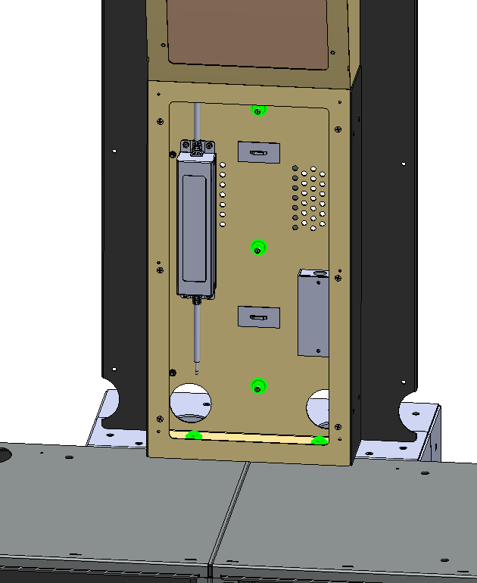

1. Secure the Small Wedge to the Pole with 3(x) 1/4 Black Flat Washers (HDW-25960-416) and 3(x) 1/4-20 Hex Nuts (HDW-20001-420). Secure the bottom of the Wedges to the Pedestals with 2(x) 1/4 Black Flat Washers (HDW-25960-416) and 2(x) 1/4-20 x .750 Black Hex Bolts (HDW-82420-075).
2. Install the left and right Endcaps (WLD-03513-305 and WLD-03513-310) on both ends of the 2(x) Pedestals. Secure the Endcaps with 10(x) 1/4 Black Flat Washers (HDW-25960-416) and 10(x) 1/4-20 x .750 Black Hex Bolts (HDW-82420-075), 5 Flat Washers and 5(x) Hex Bolts per Endcap.

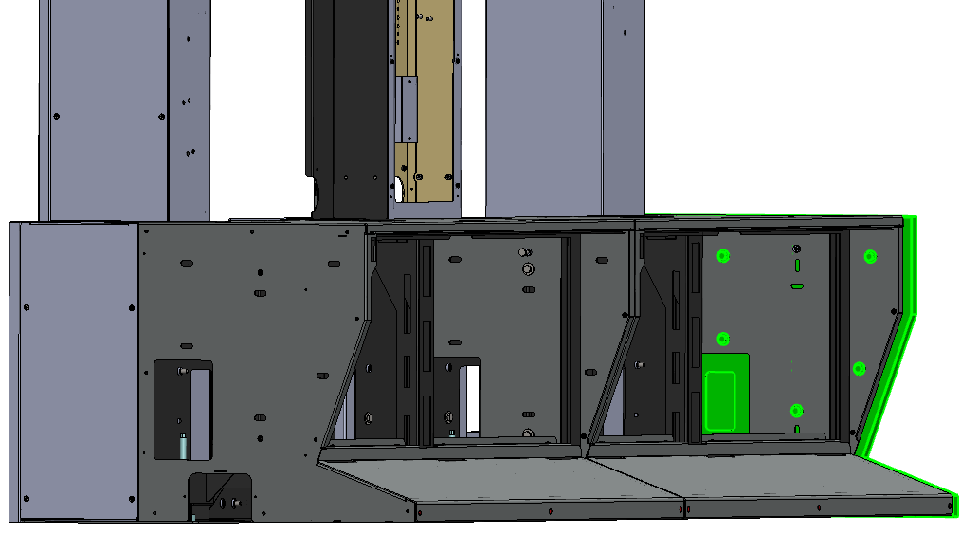

*Endcap*

*(WLD-03513-305)*

*Endcap*

*(WLD-03513-310)*

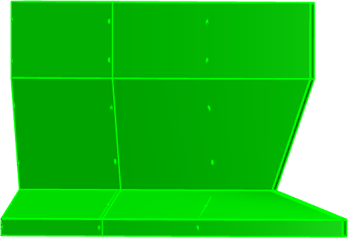

1. Secure the Small Wedge to the Top Sign with 2(x) 1/4 Black Flat Washers (HDW-25960-416) and 2(x) 1/4-20 x .750 Black Hex Bolts (HDW-82420-075).

WEDGE DATA CONNECTION

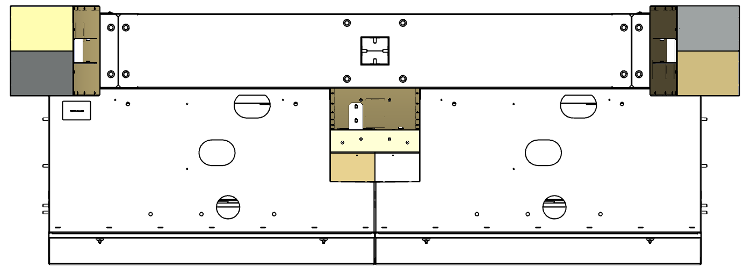

Primary

Wedge

Small Wedge

Primary

Wedge

*Connect*

*Connect*

***PRIMARY WEDGES:*** *Each Primary Wedge has an individual Power Switch; the switch can be found on the upper right side, behind the Wedge (below the Sign).*

POWER SWITCH LOCATIONS

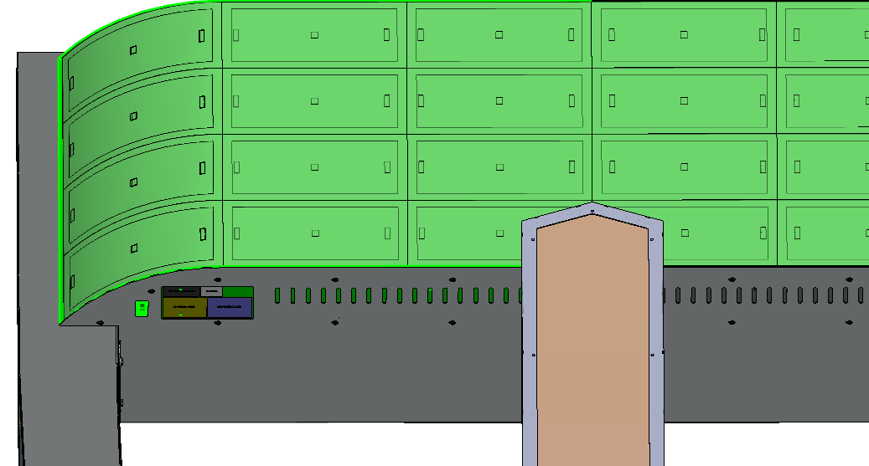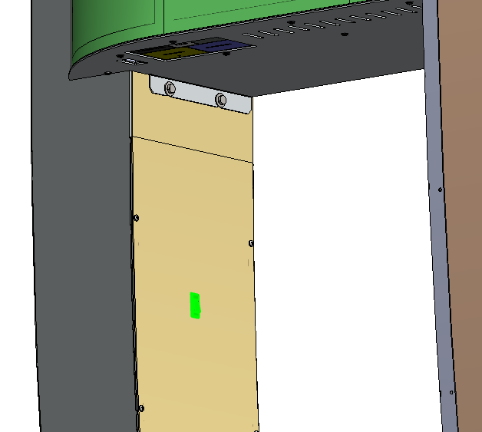

***SIGN:*** *The Sign Power Switch located underneath the left side of the Sign.*

***SMALL WEDGE:*** *Small Wedge Power Switch can be found on the upper left side, behind the Wedge (below the Sign).*

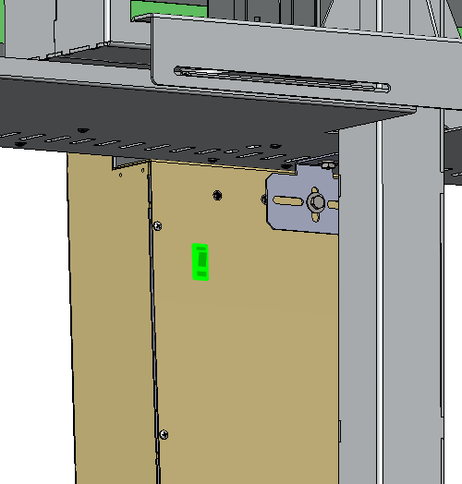

1. **Test for functionality**, verify that On/Off switch on the Sign and all Wedges are on the Off position before plugging the Power Cords into the AC outlets. Plug AC Power Cord into AC Outlet, turn the Power Switches On before test. Turn off the power Switches and unplug the AC power cord after successful test.
2. Reinstall the 2(x) Back Covers to the Sign and secure with 10(x) 1/4 Black Flat Washers (HDW-25960-416) and 10(x) 1/4-20 x .750 Black Hex Bolts (HDW-82420-075), 5(x) Flat Washers and 5(x) Hex Bolts per Back Cover.

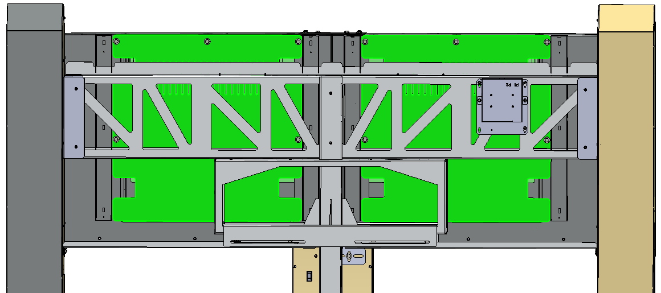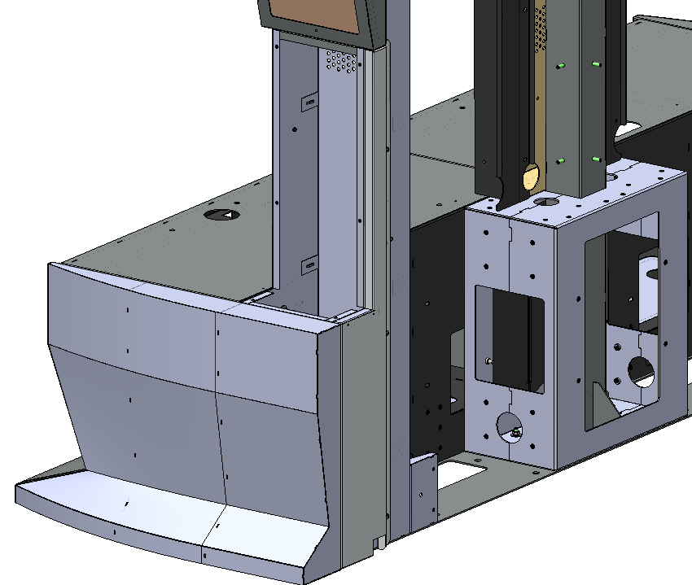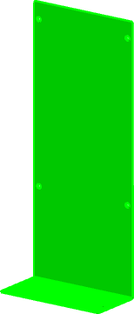

1. Reinstall the Wedge Main Doors to the Primary Wedges with 12(x) 8-32 x .375 Black Flat Head Screws (HDW-60832-375), 6(x) Flat Head Screws per Wedge Main Access Door.

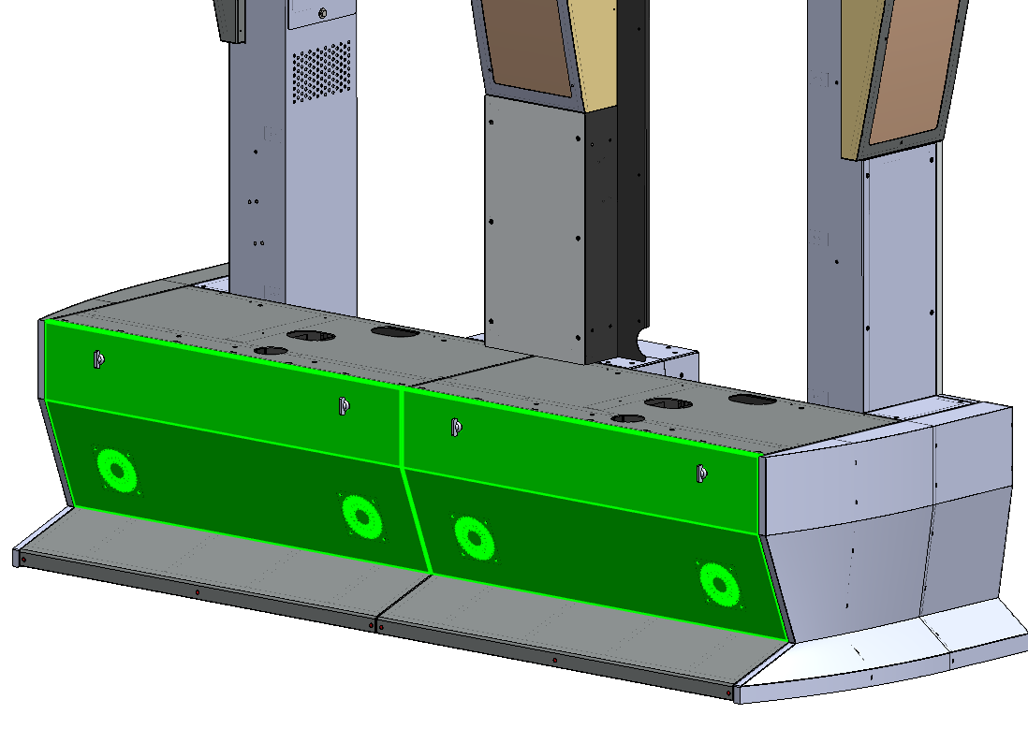

56. Reinstall the 2(x) Pedestal Main Door Panels to the Pedestals.

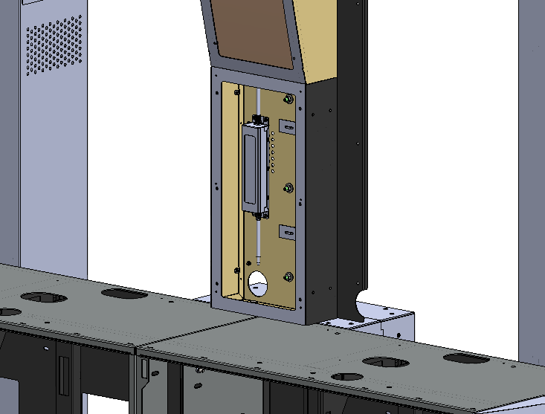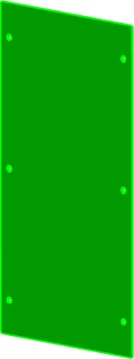

Assembly complete.

2x1 DRS VIDEO WALL

1. Reinstall and secure the Small Wedge Cover back to the Small Wedge with 6(x) 8-32 x .375 Black Flat Head Screws (HDW-60832-375).